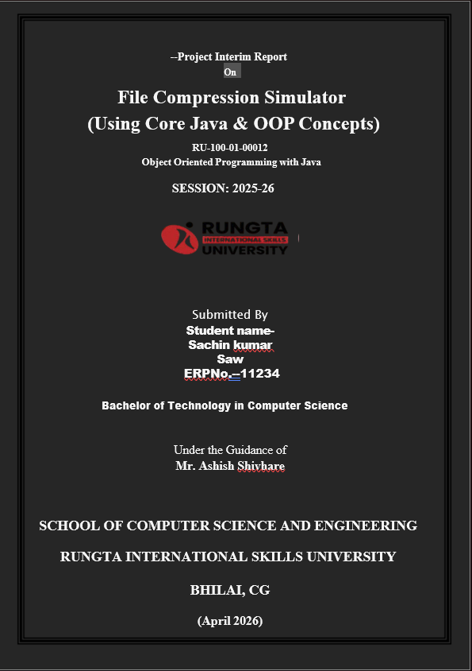


📄 ABSTRACT
This project focuses on designing and implementing a Warehouse Inventory Tracking System using Object-Oriented Programming (OOP) concepts in Java. Inventory management is essential for warehouses to ensure that products are available and to avoid shortages or overstocking. The system developed in this project helps in managing product details such as name, quantity, and minimum stock level (threshold).
The system identifies products that are low in stock and generates alerts, allowing timely restocking. It uses OOP concepts like encapsulation, classes, objects, and arrays of objects to organize and manage data efficiently. The use of the this keyword ensures proper assignment of values within objects.
This project simulates real-world warehouse operations and improves understanding of program structure, logic building, and object management. It is simple, efficient, and can be extended further with database integration and GUI features.
📘 INTRODUCTION
Inventory management plays a crucial role in maintaining the smooth operation of warehouses. Without proper tracking, businesses may face issues like stock shortages, overstocking, and mismanagement of products.
This project introduces a Warehouse Inventory Tracker system developed using Java and OOP principles. The system allows users to store and manage product details, check stock levels, and generate alerts when inventory falls below a certain limit.
The program uses classes such as Product and InventoryManager to structure the system. Each product is represented as an object, and all products are managed using arrays. The system checks each product’s stock level and compares it with the threshold value to determine whether it is sufficient or low.
This project demonstrates how real-world problems can be solved efficiently using programming concepts.
🎯 OBJECTIVES
- Store and manage product details
- Track available stock quantity
- Detect low stock levels automatically
- Generate alerts for low stock items
- Apply Object-Oriented Programming concepts
- Reduce manual inventory tracking
🌍 SCOPE
This project is suitable for small warehouses or inventory systems. It can be used to monitor stock levels and manage products efficiently.
Future improvements can include:
- Database integration
- Graphical User Interface (GUI)
- Barcode scanning system
- Online inventory tracking

💻 SYSTEM REQUIREMENTS
Hardware Requirements:
- Computer/Laptop
- Minimum 4 GB RAM
- Processor: i3 or above
Software Requirements:
- Java JDK (8 or above)
- IDE (VS Code / Eclipse / IntelliJ)
- Operating System: Windows/Linux/Mac
⚙ METHODOLOGY
The working of the system is as follows:
- Create a Product class with attributes:
- productName
- quantity
- threshold

- Use constructor and this keyword to initialize values.

- Create an InventoryManager class:
- Stores multiple products in an array

- Add product objects into the system.

- Implement a method checkLowStock():
- Loop through all products
- Compare quantity with threshold

- If quantity < threshold:
- Display "Low Stock Alert"

- Otherwise:
- Display "Stock OK"

- Display all product details and summary.
🔄 FLOWCHART
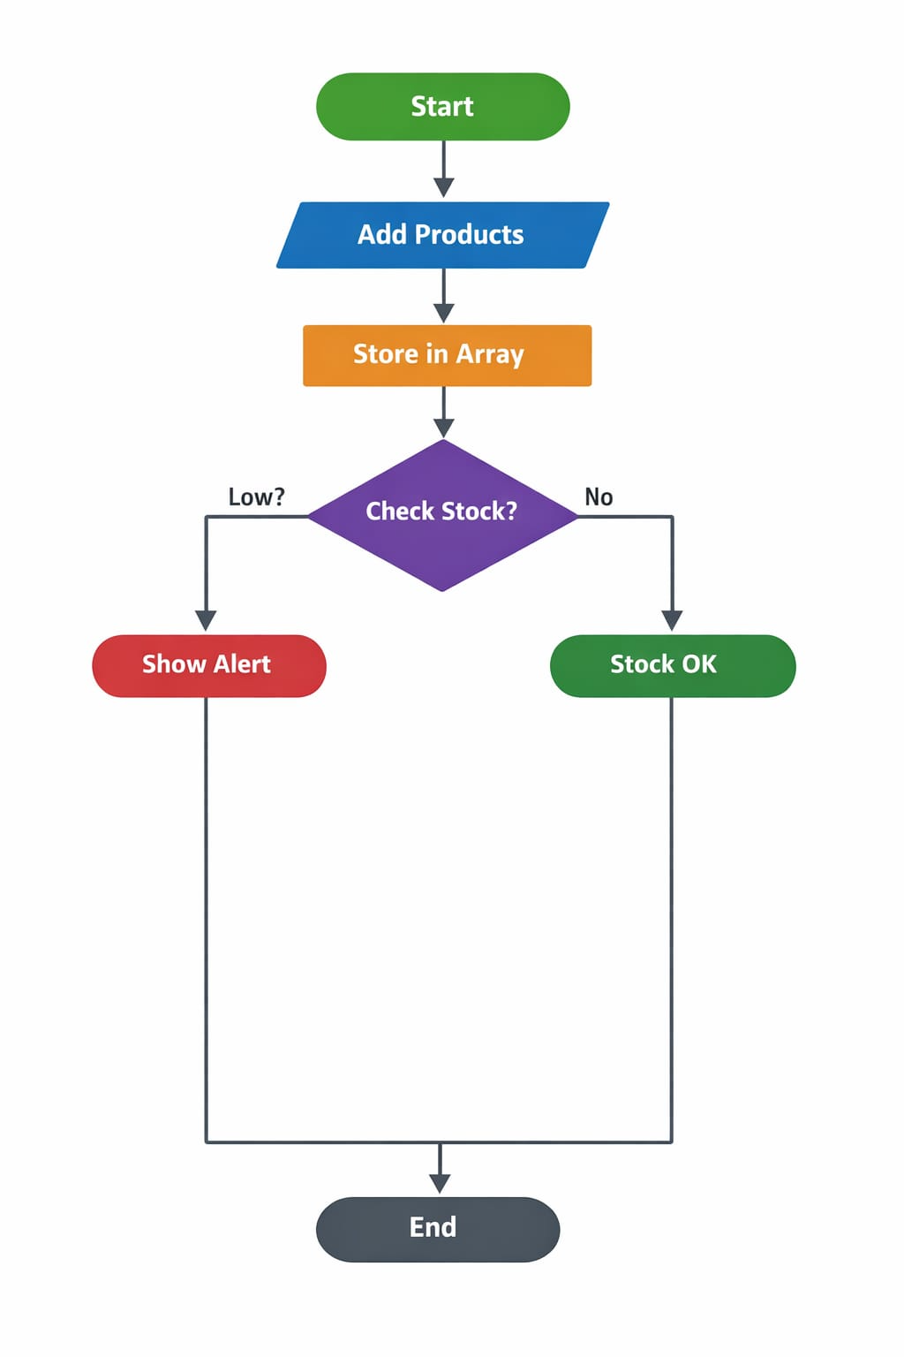

🧩 CLASS DIAGRAM

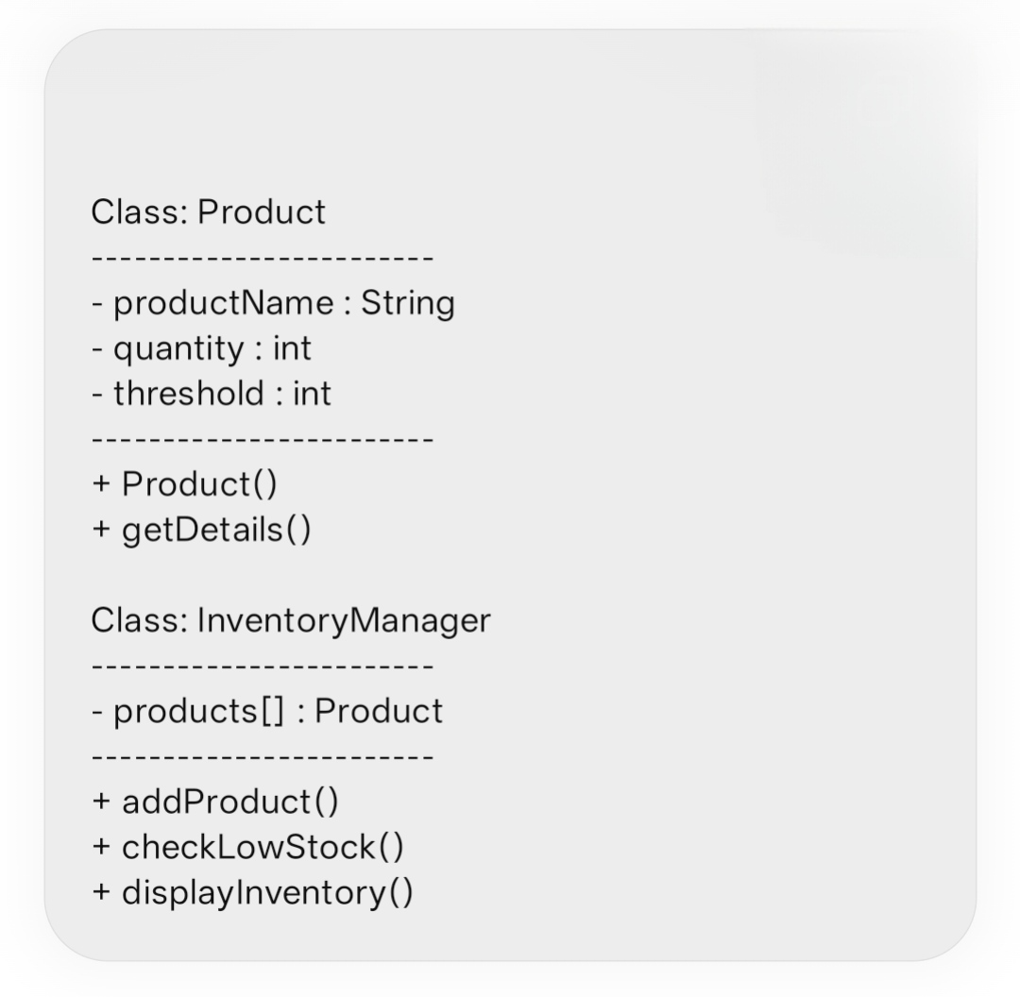

🛠 IMPLEMENTATION
Product Class
- Stores product details like name, quantity, and threshold.
- Constructor initializes values using this keyword.
InventoryManager Class
- Manages all product objects using an array.
- Contains methods to:
- Add products
- Check stock levels
- Display inventory
Main Class
- Creates objects of Product
- Adds them to InventoryManager
- Calls methods to check stock and display results

🖥 SAMPLE INPUT / OUTPUT
Input (Example Data):
- Laptop → Quantity: 15, Threshold: 10
- Mouse → Quantity: 5, Threshold: 10
- Keyboard → Quantity: 12, Threshold: 8

Output:
Checking Inventory...
- Product: Laptop - Stock OK
- Product: Mouse - Low Stock Alert!
- Product: Keyboard - Stock OK
🚀 FUTURE ENHANCEMENTS
- Add database connectivity (MySQL)
- Develop GUI using Java Swing/JavaFX
- Add login authentication system
- Implement real-time stock updates
- Add report generation feature
📊 GANTT CHART (Text Format)
Task Duration
Planning 2 Days
Design (Classes) 2 Days
Coding 4 Days
Testing 2 Days
Documentation 2 Days
✅ CONCLUSION
The Warehouse Inventory Tracker project successfully demonstrates the use of Object-Oriented Programming concepts in Java. It provides an efficient way to manage inventory and detect low stock levels. The project improves programming skills, logical thinking, and understanding of real-world applications. It can be further enhanced with advanced features for practical use.
📚 REFERENCES
Book:
[1] H. Schildt, Java: The Complete Reference, 11th ed. New York: McGraw-Hill, 2018.
Website:
[2] Oracle, "Java Documentation," Oracle. [Online]. Available: https://docs.oracle.com⁠�
Journal:
[3] A. Sharma, "Inventory Management Systems," International Journal of CS, 2020.

